




Changes in Matter

What is Matter?

Do matter changes?

How it changes?

What’s the Matter WebQuest?

A WebQuest for Third Year High School (Chemistry)

Designed by:
Charta S. Sejismundo
char_gem08@yahoo.com

Introduction | Task | Process | Resources|
Evaluation | Conclusion | Return to Introduction|

Introduction
What is matter? Do they really matter to us? Do they change? Do these changes play significant role in one’s life? How?




Matter is everywhere. Matter is defined as anything that occupies space has mass and weight. Everything found in the universe are matter from the tiniest to the largest. Is this enough explanation for matter? Exactly no! How can we get a concrete understanding on these? To have a much clearer view on this, that we have to find out…



Tasks

You and your team will be responsible for producing one specific creative report on all about matter.
- Read and comprehend the topic given to you. You are give (10 – 15) minutes time to do the reading.

- Collaboratively create a (10- 15) minute creative report on the topic given to you using appropriate images, voice-over narration, etc.).
- Present the creative reporting to the class. The given time allotment will be (10- 15) minutes only.
- Work as fast as you can to cope up with the time allotment given.
- Use student study guides to informally assess the effectiveness of the creative report presented.
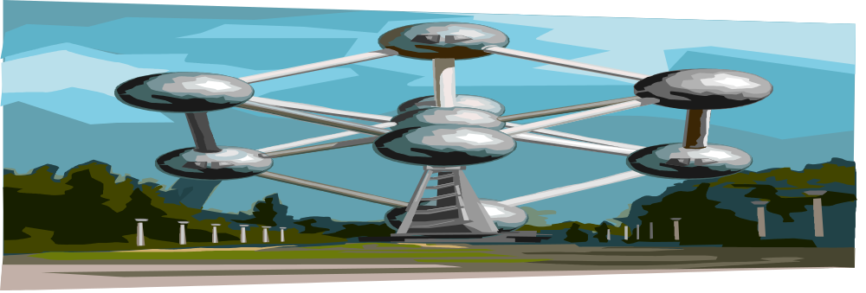

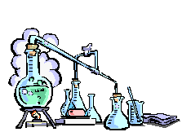
The Process

1. Consult the grading rubric to make sure you create the best possible creative report.

2. Each member of the group conducts research and makes more readings of the topic given in order to contribute materials essential to the presentation of your group's creative report. Research should incorporate a variety of resources including text and review books, materials from the Media Center, as well as Internet resources. A list of all of the research sources will be kept so that it can be incorporated into written and PowerPoint slide-based Works Consulted list using proper citation.

3. Divide up the four roles among your group members.

4. Access the web page for your specific role listed in the Group Roles section. There, you will find a thorough description of your role and the responsibilities associated with it.

5. Organize the group's research and prepare it for use in the report’s study guide and PowerPoint presentation.
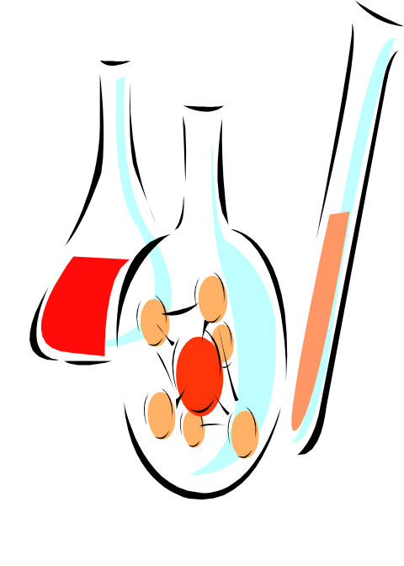
6. Prepare a study guide and script to use for the narration and PowerPoint presentation of your creative report. For the Power point presentation, you are only given a maximum of 15 slides thus, you will give or present the summary only on the slides.
7. Construct your group creative report collaboratively. Present it to the whole class with an aid of the PowerPoint. For the presentation, you are given 20- 30 minutes allotted time.

8. Edit and check closely your script before submitting it to the teacher.


9. Double check the script of the constructed creative report using the study guides.

10. Each group will assign individual grades based on the work of each membe, and the teacher's evaluation of the group segment.



Resources

Matter
http://www.chem4kids.com/files/matter_intro.html
http://www.usoe.k12.ut.us/CURR/SCIENCE/sciber00/8th/matter/sciber/physchng.htm
http://www.schools.pinellas.k12.fl.us/educators/tec/davis2/matter.ppt/sld010.htm

Physical and Chemical Properties of Matter
http://www.chem.tamu.edu/class/majors/tutorialnotefiles/intext.htm
http://www.elmhurst.edu/~chm/vchembook/104Aphysprop.html
http://www.chem.vt.edu/RVGS/ACT/notes/Properties_of_Matter.html
http://www.tannerm.com/properties_of_matter.htm
http://www.google.com.ph/search?hl=tl&q=Physical+properties+of+matter&btnG=Hanapin+sa+Google&meta=
http://www.mi.mun.ca/users/edurnfor/1100/atomic%20structure/sld029.htm

Law Governing Chemical Changes
http://dbhs.wvusd.k12.ca.us/webdocs/Equations/Conserv-of-Mass.html
http://www.apsu.edu/ROBERTSONR/TSTA%20Presentation/DEMOSshort.pdf
http://www.iscid.org/encyclopedia/Law_of_Multiple_Proportions
http://chemistry.about.com/library/weekly/aa012903a.htm
http://www.can-do.com/uci/ssi2002/chemicalreactions.html


GROUP ROLES

Researchers – Do all the readings and supply all the facts about the topic. They will be the one who will provide for the summary of the whole topic.
Script Writers – Do the making of the script basing from the data given by the researchers.
Power Point Presenter – Do the making of the PowerPoint presentation slides and present this during the creative reporting presentation so as the viewers will be guided on the happenings.
Reporters – Do the creative presentation in a form of report in the class. They will to report on the researches given to them by the researchers in their own different styles.

Propsmen/Back-up – Do the technical support for the presentation. They are the people behind the scene who take charge of all technical aspects in the presentation of the creative report including the materials needed by the reporters (as background music, decorations, costumes, etc.)


Evaluation
Creative Reporting Grading Rubric
As we discussed in class, a high-quality and creatively presented report has a certain look and feel to it, which we are going to present inside the class. Based on the criteria that we developed in class, please keep the following grading rubric in mind as you collaboratively create your segment:
Criteria | Score
Factual Content-The information included in the creative report is accurate and relevant to the topic, and includes all of the required items.
Use of Primary Sources-Several relevant primary sources (e.g., photographs, personal accounts, etc.) have been used to provide information about the content contained in the creative report.
Media Use-The sounds, images, and animations are used are both relevant and purposeful.
Organization-The creative report is well organized in a logical manner, making it easy to understand the information that is being presented.
Presentation- In the presentation, they made use of the primary sources as its means of transmitting information for the creative report. The ideas presented are relevant and compliment the media selected for the creative report.
Report Guide-The report guide acts as an outline of the creative report, providing students with a resource to review the material presented. The study guide should closely follow the presentation of the documentary.
Total Points
Grade
Each of these criteria will be rated according to the following point scale:
Score | Meaning
3 | Excellent-The criteria has been met in every possible way, and may even exceed expectations.
2 | Acceptable-The criteria has been mostly addressed, however, there is room for improvement.
1 | Sub par-Some elements have been met, but most of the criteria fails to be addressed.
0 | Incomplete-The criteria has not been addressed in any meaningful way or has not been completed.


Conclusion

After completing this WebQuest, you will understand the major concepts and ideas about matter, changes it undergoes and the applications of these changes to our life. Check your understanding of these ideas by considering the following essential questions:

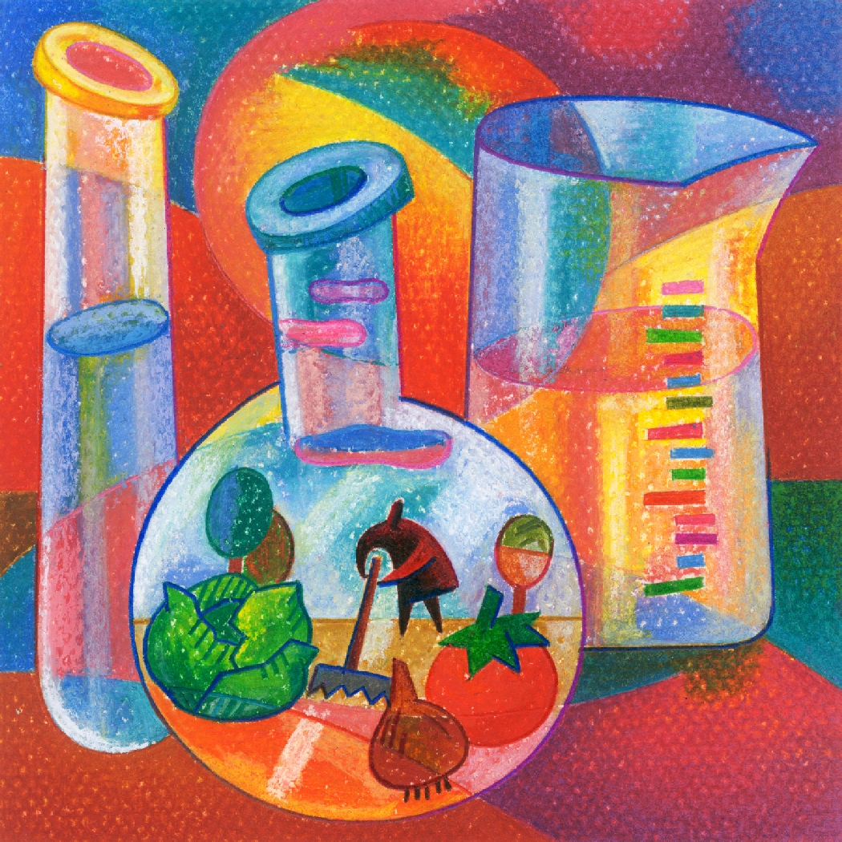
- What is matter? Does it really matter on our respective lives?
- What are the importance of matter and the changes it undergoes in our lives, technologies, in the industries, in our respective homes, and even in our environment which greatly improve our lives?
- What are the evidences of chemical reactions?
- What are the laws which govern these changes? Explain each laws.
- What are the types of chemical equations?
- What are the applications of these reactions in the industry (– soap making, fermentation, etc.)

(May 08, 2008 )
Template adapted from Bernie Dodge, http://edweb.sdsu.edu/webquest/LessonTemplate.html

